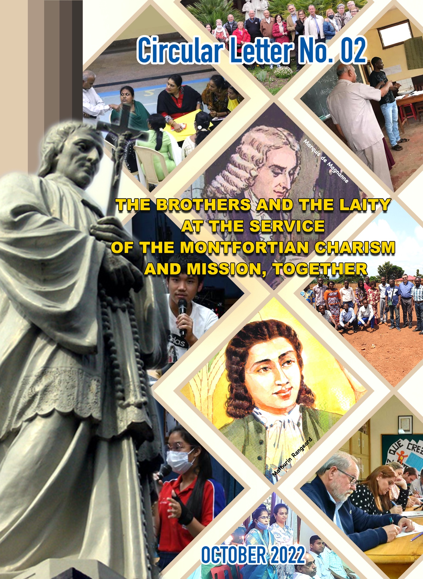
Table of Contents
Introduction 3
1. Historical Overview 6
2. Montfortian Spirituality – A Treasure of the Church 12
2.1 Charism 15
2.2 Montfortian Charism 16
2.3 We are also Gabrielites 17
2.4 Montfortian Gabrielite Charism 18
3. Partnership 21
3.1 Understanding of Partnership 21
3.2 Partnership between Consecrated Life and Laity 23
4. Church, the People of God 25
5. Shared Mission in the Catholic School is of all and for all 28
5.1 Links and Processes towards the Charismatic Family 29
5.2 The Brothers and the Lay People: being with and for others 31
5.3 We Train and Accompany each other 32
6. Associates are Our Close Partners 35
7. Montfortian Education - Our Mission 37
Conclusion 39

Introduction

The Second Vatican Council gave great encouragement to the Religious to renew themselves and their Congregations, while also challenging the laity by the universal call to holiness found in the Council’s central document. At first the Religious and Laity sought to answer this call in their own way, but soon there would be an exciting new development as Religious and Laity together found a new approach to fulfilling the vision of the Council: Laity seeking a viable spirituality; Religious trying to show their charism as relevant to the contemporary world. The current phenomenon goes by various names, such as Lay Association, Affiliation or Lay Associate Membership of a Religious Institute, Third Orders, etc. But the central reality is the sharing of charism, life and spirituality of Religious Institutes by lay people.
In the Post-Synodal Apostolic Exhortation, Christfideles Laici of 30.12.1988, the Holy Father John Paul II declared prophetically that the third millennium will be of the lay people. There has been a number of studies on the role and mission of the laity in the last fifty years. The documents of Vatican II, specifically Lumen Gentium, Apostolicam Actuasitatem and Ad Gentes, the Apostolic Exhortation Christifideles Laici and the Code of Canon Law CIC 1983 have dwelt on laity quite elaborately.
As stated in the Preamble of the MGA Charter, brought out in October 2019, for us the Montfort Brothers of St. Gabriel, the Montfortian Gabrielite Associate Movement, has been in a process of evolution, to be in tune with the teachings of the Church, and its efforts to give the laity its rightful place. The powerful words of Pope John Paul II addressed to the Montfortian Family in 1997, gave a new impetus to us: “The Montfortian Spirituality and charism are treasures of the Church. It is our responsibility with the whole Montfortian Family and others to promote them”. The document entitled “Partnership – General Guidelines” brought out in March 2009 was the first attempt of the Montfort Brothers of St. Gabriel to give a certain structure to the Montfortian Gabrielite Associate Movement in the Congregation. This was followed by the MGA Charter brought by the International Commission for Partnership.
The Circular Letter on Partnership – October 2022, is yet another attempt to reiterate our commitment to promote Montfortian Gabrielite Associate Movement in all its varied dimensions. This Circular Letter gives an historical overview of the movement in the Congregation, beginning with the 29th General Chapter held in 2000, gives the specific characteristics of our Montfortian and Gabrielite charisms, gives a better understanding of the concept of Partnership in the Church and the need and importance of collaboration between the Brothers and our Lay Associates in our shared mission. A set of questionnaire is also included to facilitate better reflections at the personal and community levels. On behalf of the whole Congregation, I wish to take this opportunity to thank Bros. Dionigi Taffarello, Paulose Mekkunnel, and our Associates María Jesús Ramos Rubio and Gemma Justo Medrano from Spain, and Zera Goh from Singapore, for their significant contributions.
It is significant that this Circular on Partnership comes out at a time when the whole Church is engaged in a study and implementation of the new Constitution of Pope Francis on the restructuring of the Vatican Curia: Predicate Evangelium (Preach the Gospel). The final document published on 19th March 2022, provides the vision of a Curia that is evangelical, service-oriented, promotes synodality and highly professional. Above all, it gives a more decisive voice to the laity in the Church affairs. In fact, it was a reform that was promised at the beginning of the Pontificate of Pope Francis in 2013, several aspects of which have already been implemented.
In his Apostolic Letter for the Year of Consecrated Life (2015) Pope Francis speaks ‘not only to the consecrated persons, but also to the laity who share with them the same ideals, spirit and mission’. Pope Francis reminds the consecrated persons, “Indeed around each religious family, every Society of Apostolic Life and every Secular Institute, there is a larger family, a ‘charismatic family, which includes a number of Institutes which identify with the same charism, especially lay faithful who feel called precisely as lay persons to share in the same charismatic reality”. They seek to live the spirit and share in the charism and apostolate of the religious family to which they are linked.
Bro. John Kallarackal, SG
Superior General

Historical Overview

Partnership with the Laity is part of our history from its very beginning. When Louis Marie de Montfort, endowed with the special gift of the Holy Spirit, began his missionary life, lay people began to gather around him. Some of them became his close disciples; Marie Louise Trichet was one of the first among them, and eventually she become the Co-Foundress of the Daughters of Wisdom. Mathurin Rangeard was another early close Associate of Montfort; he remained as such throughout the missionary life of Montfort and beyond. Many from all walks of life, including Father René MULOT, joined Montfort in one mission or another of the many missions he preached during the last 10 years of his earthly life. Towards the end of his life, four of them joined Montfort by making the vows of Poverty and Obedience in his hands to form the Brothers’ Community of the Holy Spirit, as mentioned in his last Will, while all the others remained as Partners and Associates.
Beyond his death too, it was the lay men and women like Marquis de Magnanne, Madame de Bouillé, and René Joseau who were responsible for bringing Marie Louise Trichet and community to Saint Laurent-sur-Sèvre; they also facilitated the restarting of the Community of the Holy Spirit. It was the presence of these communities around the tomb of Louis Marie de Montfort that preserved and promoted Montfortian Charism for the future generations.
Though partnership with Laity is part of our Montfortian Gabrielite history and culture, it was the post Vatican II awareness of the role of the laity in the life and mission of the Church that gave us a new impetus to develop systematically the concept and practice of Partnership with the laity in our life and mission. The letter of Pope John Paul II, on the occasion of the Golden Jubilee of the Canonization of Montfort, to the Superiors General of the Montfortian Congregations, exhorting them to open the doors of their Congregations to the laity so that they too can enter and participate more closely in our Charism and mission, became the immediate incentive to start the Associate Movement in the Congregation.
The 29th General Chapter (year 2000), in which a few lay people participated, did the Ground Breaking process for building up the Partnership edifice in the Congregation. In the context of the Chapter Theme: Montfortian Missionary Dynamism for a Just Society, Towards the Kingdom, the following orientation was given: “Wherever possible, at every level in the Institute, we will set up the necessary structures to work for justice, in partnership with the Montfortian Family, other religious groups, lay people, people of other faiths…” (Message of the 29th General Chapter 2.1 p.3). The Chapter also gave a framework within which to work out the Partnership Programme: “Our Partnership with the ‘Partners of Brothers of St. Gabriel’ will be realized in four stages:
- Formation to leadership and partnership,
- Sharing of the Montfortian Gabrielite Charism,
- Sharing of the Montfortian Gabrielite Mission,
- Sharing of our Identity and Mission.

In the light of the above direction from the General Chapter, every Province in the Congregation began to work on the Associate-Project. It became a Montfortian Associate Movement in the Congregation. The Central Administration came out with the “Partnership, General Guidelines” in 2009, which gave more clarity to the concept.
The 30th General Chapter (2005-06) by way of practical suggestions, encouraged the Provinces to take initiatives to create the necessary infrastructures to promote partnership with the laity at different levels. It was a Chapter in which lay representatives from all the Provinces participated, giving further emphasis to the need for entering into Partnership with the laity in order to take our Charism and mission to the future more effectively: “The Montfortian spirituality and charism are treasures for the Church. It is our responsibility with the Montfortian Family and others to promote them. It will strengthen in us the conviction that this spiritual treasure can be lived and shared with others.” (Message, No. 36)
“Today, the world is marked by networks of solidarity, and the Church by the spirituality of communion. We are invited to live more and more in partnership with others and this is to be extended to all people of good will” (Message, No. 37).
“Being aware and convinced of the richness of the Montfortian Treasure placed in our hand, we want to live it more intensely and to spread it more widely”. (Message, No. 41).
As a result, Montfortian Gabrielite Associates became a reality in almost all the Provinces of the Congregation with varied names and characteristics. The Bangalore, International Partnership Meeting held in 2008, reflected more deeply into its history, theology and practical consequences to the Congregation. It lead to the updating of the ‘Partnership General Guidelines’ with a new title: “GENERAL GUIDELINE ON PARTNERSHIP, LAY ASSOCIATES, COLLABORATION AND NETWORKING”.
Future Montfortian
Charismatic Family

COLLABORATORS
ASSOCIATES
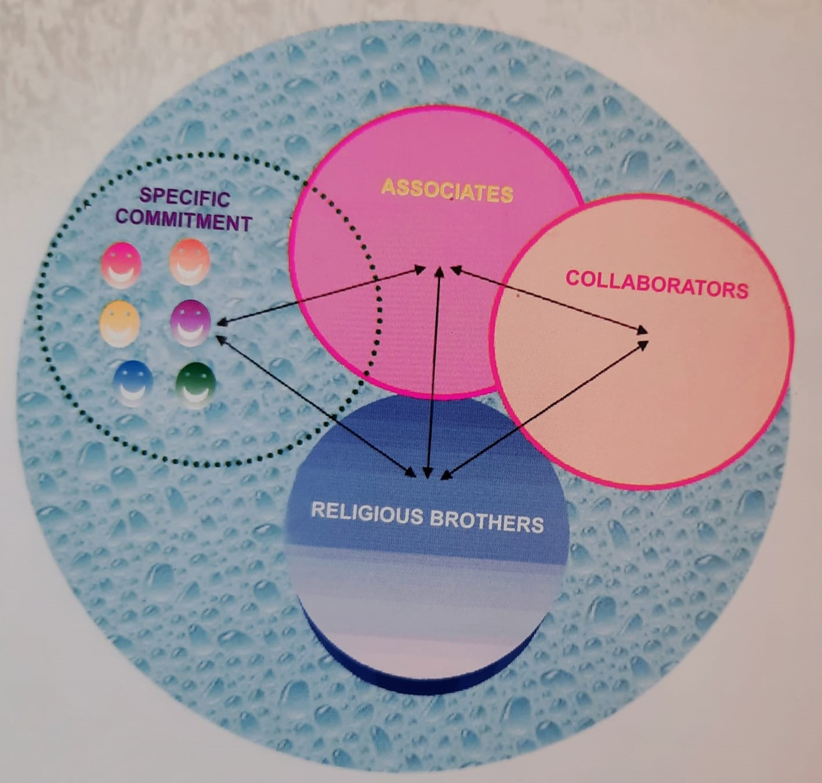
The 31st General Chapter brought in further clarity by describing the would be Montfortian Gabrielite Family as a community of Brothers, Associates, Collaborators and those individuals who would like to make private commitments in link with the Congregation. Making room for individual Lay Montfortians was the specific contribution of the 31st General Chapter. It stated: “Catholic adults, coming from different backgrounds, who feel a call for a deeper Christian commitment according to the Montfortian spirituality, could take, individually a private commitment in link with the Congregation” (G.C. 31; No. 27).
The 32nd General Chapter, reviewed the progress of the partnership movement in the Congregation. It found that the Montfortian Associates in different forms are present in all the Provinces; many important studies and consequent decisions, including the General Chapter orientations, concerning Partnership with the Laity, have been made but much of it has not been realized on the ground yet. The Chapter mandated the Central Administration to constitute an International Commission for Partnership to guide and monitor its progress in the Congregation. The Commission had three meetings; the MGA CHARTER which is approved by the Superior General and Council and sent to the Provinces for implementation, is a product of these meetings. It is an attempt to create a coordinated core group of Associates within the diverse existing Associate groups in the Provinces. We hope that as the Provinces move into the implementation of the Charter, more coordinated progress can be made in realizing the vision of an enlarged Congregational Family, in close partnership with the Laity.

Questions for Community Sharing
- The Community of the Holy Spirit is our Montfortian foundation, as such we are the direct inheritors (according to the Will of Montfort) of Montfortian heritage: the Charism, Spirituality and Mission. Are we convinced of it? Do we claim it and make it our own?
- The Partnership we advocate springs from common obedience to the Spirit. "For a Synodal Church: communion, participation and mission" is the theme of the Synod on Synodality. At a time when the Church and all its components (priests, religious, laity) are called to renewal, how do you perceive the question of Partnership in your Province and in the Congregation? What challenges do you encounter in implementing Partnership? How does the Partnership work at the level of your Province presently? Is it a fruitful experience?

Montfortian Spirituality – A Treasure of the Church

We, the Montfortian Gabrielites, along with other members of the Montfortian Family, are the Inheritors of the Montfortian Charism, which we believe is a great divine treasure given to the Church through us. We have the responsibility not only to preserve it but also to share it with the wider world. In this context, it is important for us to take a brief look at our history which often lacks clarity.
The last 10 years (1706-16) was the most significant period of Montfort’s missionary life. After meeting Pope Clement XI and getting confirmed about his future mission and being conferred with the title “Apostolic Missionary”, Montfort returned to France on foot, wearing the confidence and authority of an Apostolic Missionary. He was an unrelenting missionary ever since, renewing and reviving the Church in his on hometowns and villages through a process of renewing their baptismal insertion into Jesus Christ. It is estimated that Montfort preached about two hundred and more missions of varying duration and the core of all these missions was the renewal of the Baptism into Christ, the Eternal and Incarnate Wisdom of the Father.
At the height of his missionary carrier Montfort desired to have an association of priests to carry on his mission; he wrote a Rule for them in 1713 and called it “Company of Mary”. But divine providence took its own time to realize it. It was also the time (1711 – 16) when Montfort got himself deeply engaged in the formal education, as part of his commitment to the dioceses of La Rochelle and Luçon, where it was being adopted as a means of effective evangelization, especially of the poor. Seeing it as an added opportunity provided by the divine providence, Montfort not only aided the diocesan authorities to implement their education policy, but also organized schools by himself which he entrusted to his disciples. The first school he organized was for the girls, which he entrusted to his beloved disciple Marie Louise Trichet and her companions in 1715. Eventually this group became the Congregation of Religious Sisters called “Daughters of Wisdom”.
It is in this context of Montfort’s involvement in School education, on Pentecost day 1715 (as per tradition), 4 young men joined Montfort by taking the evangelical Vows of Poverty and Obedience to form the “Community of the Holy Spirit” for Charity-Schools. It is to this community of the Holy Spirit that Montfort bequeathed his heritage, through his last Will, in the form the small possessions he had, asking it to be preserved for their use and those whom Providence will bring to this community in the future: “… I confide to His Lordship the Bishop of La Rochelle and to Fr. Mulot, my small piece of furniture and mission books, to be preserved for the use of the four Brothers... and for the use of those whom divine providence will call in to the community of the Holy Spirit …” (cf. the Will of Montfort).
The Community of the Holy Spirit was the only legal entity, as the Will was registered, that existed beyond the death of Montfort. It was in the name of this community that the land called “Chêne-Vert” (the holm-oak house), was purchased at St. Laurent-sur-Sèvre in April 1721 (cf. Card. Tisserant, Montfort and the Origin of the Brothers of St. Gabriel, p. 263). It was in this house where the Community of the Holy Spirit re-started in 1722 under the leadership of Fr. Mulot; now as a community of Brothers and Priests, engaged in the missions of education and mission-preaching. The Community of the Holy Spirt continued to grow and function through 18th century in France but the French Revolution which came towards the end of the century destroyed most of what was built up till then. It was this Community of the Holy Spirit, in its minuscule form, along with the Daughters of Wisdom that Fr. Gabriel Deshayes took over as its Superior, in 1821. Under his dynamic leadership a phenomenal development took place which paved the way for the community of the Holy Spirit to become two separate vibrant Congregations of “Brothers of St. Gabriel”, and the “Company of Mary”; “Daughters of Wisdom” too grew manyfold under his leadership (cf. Research work of Bro. Bernard Guesdon).
What happened under the guidance and inspiration of Gabriel Deshayes was a Re-foundation especially for the Brothers. Hence Brothers are inheritors of the Gabrielite Charism too along with the Montfortian – Montfortian Gabrielite Charism.
It is this Montfortian Gabrielite Charism that has come down to us traveling through the lanes and by lanes of history across the world. The call of the time is to preserve, promote and share it with the wider world in partnership with the laity.

Charism

Charism in the Pauline parlance is the gift of the Holy Spirit given to an individual or a group of persons for the common good of the community. “There is a variety of gifts but always the same Spirit... to each is given the manifestation of the Spirit for the common good” (1 Cor. 12:4,7); Rom. 12:4-8).
Vatican Council II, speaking about religious life, highlighted its charismatic nature by defining the evangelical counsels as "a gift of God which the Church has received from her Lord and which by his grace she always safeguards" (LG 43). This gift, attributed to the renewing action of the Holy Spirit, finds concrete expression in those outstanding men and women (LG 45) who have given new religious families to the Church, which has then officially authorized them (LG 45 and PC 1). The Council also speaks of "the spirit and aims of the founders" which characterize the particular nature of each religious family in the Church (PC 2 and 7-10) and which must be "known and observed".
The document Mutuae Relationes of Pope Paul VI offers us a description of charism in these words: "The charism of the Founders is the fruit of the Holy Spirit passed on to their disciples who must put it into practice, safeguard it, deepen it and develop it constantly in harmony with the Body of Christ in perennial growth” (Mut. Relat. n.11).
Putting together all these Scriptural and Church teachings on Charism, we can say that the Charism of the Founder is the Faith-Vision he receives from the Holy Spirit. His spirit and spirituality along with the Congregation evolve around this Faith-Vision.

Montfortian Charism

It is the gift of Wisdom, which he ardently desired and constantly prayed for, that Montfort received from the Holy Spirit. It resulted in his intuitive insight into the mystery of Redemptive Incarnation: his perception of Jesus Christ as the Eternal and Incarnate Wisdom of God; his experience of the Cross of Jesus Christ as the supreme expression of God’s wisdom and love; his understanding of the role of Mother Mary in God’s plan of human salvation and his understanding of preferential option for the poor – “Open to Jesus Christ”; all these together formed the Charism gift he received.
The totality of this experience is the Montfortian Charism-experience (Montfortian God-experience). It resulted in his Faith-vision of the Divine-human reality that propelled Montfort to become the passionate missionary that he was: the preacher, the writer, the poet and the artist, the educator and the founder. It all together enabled Montfort to become a prophet like Jesus, in his time and place.
The many organizations around the world, especially the three Religious Congregations in which the Montfortian Charism is effectively alive today, is a proof of its potency and intensity. It has travelled down the turbulent lanes of history to reach us. In this process, we believe that our Montfortian Charism got enriched, on the one hand by its contact with many different cultures and passing through many eminent personalities, and on the other hand it enriched these cultures and personalities.

We are also Gabrielites

It was the audacious faith-commitment of Fr. Gabriel Deshayes to the Montfortian family that paved the way for the re-foundation of the Brothers as the Congregation of the Brothers of St. Gabriel. Being a Congregation of the Religious Brothers working in the privileged field of education, is part of our Gabrielite identity. A Religious Brother is a brother of Christ and a brother like Christ (VC. 60); called to be “a prophetic memory of Jesus-Brother in the Church”, consecrated to proclaim to the world the Lord’s words: "And you are all brothers” (Mt. 23:8) and to keep alive in the Church-Communion the “obligation of brotherhood as a confession of the Trinity” (VC 60,41,46; Identity and Mission of Religious Brothers in the Church, 2015, No.6).
These are fundamental to the life and mission of a Religious Brother and therefore part of our Gabrielite Charism. It is in the light of this self-awareness that we declared ourselves as “Authentic Leaders for a Greater Brotherhood” in the 31st General Chapter.

Montfortian Gabrielite Charism

The Montfortian Gabrielite Charism is to live passionately the Montfortian Faith-vision as a Religious Brother of St. Gabriel. It is being Brothers of Jesus and Brothers like Jesus, passionately committed to lead humanity, through the medium of Montfortian Education, toward becoming a fraternal community of the Children of God, Jesus’s own vision for Humanity which he called the “Kingdom of God”. It is to be lived in the dynamic process of consecrating oneself to Jesus Christ, the Eternal, Incarnate, and Crucified Wisdom, through the hands of Mother Mary for the Kingdom of the Father.
Montfort lived the Charism he received through his total surrender to Jesus Christ, the Eternal, Incarnate and Crucified Wisdom of God. For him it meant living his Baptismal insertion into Jesus Christ seriously, for himself and for others. This loving, free surrender to God's plan, Montfort believed, could renew us in the Spirit so that we may "carry out great things for God and for the salvation of souls" (cf. The True Devotion, 214). His motto: “God Alone”, was a practical expression of his total immersion into Christ in Baptism and the rejection of all that could not go with it. For Montfort, “To know Jesus Christ the Eternal and Incarnate Wisdom is to know enough; to know everything and not to know Him, is to know nothing”. Emerging from this “Baptismal core” there were other aspects to his spirituality: he became a passionate preacher of the Gospel in the light of the enlightenment he received, his commitment to the mystery of the Cross as the supreme expression of Divine Wisdom, his absolute trust in the divine providence, his love for the poor and marginalized people of his time, his deep insight into Mary’s spiritual maternity in God’s plan of human salvation; all these and more led Montfort to live a deeply contemplative-active life, totally committed to his master, Jesus Christ the Eternal Incarnate Wisdom, through the hands of Mother Mary. It is this Charism lived and enriched by thousands of men and women down the centuries that has come down to us. This is the Charism we have inherited which we want to live and share with others.

Questions for Community Sharing
- The Montfortian Gabrielite Charism is a gift that has been entrusted to us and which we have a duty to share especially with our Collaborators and Associates. In what way is our Community, our Province trying to share this gift? What are the positive effects (in the life of the Community, in our Institutions, in our Apostolate) of making our Collaborators and Associates sharers in this gift?
- Being Montfortian Gabrielites, we live our Montfortian Charism as Religious Brothers; passionate disciples of Jesus, proclaiming the Kingdom of God as brotherhood and sisterhood of all men and women in Jesus Christ. Do we see our Vocation as such? What conscious efforts we make to realize it in our daily life?

Partnership

Understanding of Partnership

To put the concept of Partnership in a practical context, we can compare it to a relationship between two people: they both need to be happy and satisfied for the relationship to endure. The Business field provides many definitions of what Partnership is or what it is not. People often refer to Partnership in a more "formal" way than we just described it.
Partnership is the integrated management of a process involving two different parties, acting as if they were one entity. Partnership occurs in many forms. Partnership arises when, in a course of its work, a party involved in a business incorporates a cost or activity of its counterparty. Similarly, when one party seeking to help it vis-à-vis, provides them knowledge and working methods that they lack, this is considered a partnership. They do so because they benefit from their own value creation process. The more a party values its business partner, the more it values itself.
Therefore, the partnership is not a generic form of collaboration or even a simple relationship of trust. It is a long-term business relationship based on rules of reciprocity. What is often missing from definitions of 'formal' partnership is a reference and attention to the skills and behaviors needed to build a true partnership. This may explain the relevance of the comparison used at the beginning of this part. In a love story, it is clearly easy to identify attitudes based on reciprocity:
- A common desire, which in the Business Field, is defined as the value objective or the shared goal that motivates the creation of the partnership.
- The ability to listen, pay attention, focus on the needs of the other, to really understand what values the partner. Not stopping at one's own perception of values and a one-sided criterion for evaluating the result to be achieved. These are methods, which prevail in the business field, transform the partnership process into a continuous negotiation, without any win-win criteria in support.
- Initiative and respect for defined and shared rules. In business, Partnership means being able to identify new or different solutions for the partner and to invest in helping to create greater values. Therefore, planning, conflict resolution, new ideas, and, why not, generosity in developing solutions are essential to business success. However, both the parties should have an explicit and clear understanding of the rules of the game. They should act in a spirit of reciprocity and exchange for a successful partnership.
This last point is probably what makes partnerships difficult to trigger and maintain in the business field and in enterprises. In the business world, it is really difficult to combine rules, boundaries, rights, and duties with initiative and generosity. The fear that openness will be misused and considered a sign of naivety makes stakeholders focus on regulations, rights, duties, and 'conventional' aspects of the partnership. On the contrary, in partnership relationships, one should always leave room for creativity, openness, and trust towards one's partner. Otherwise, if everything is regulated solely on the basis of exchange, partners run the risk of wasting time "calculating reciprocity" in detail: every investment I make towards you must bring me a gain, a return on investment. And the same applies if you invest in me. In doing so, partners forget the initial aim of the partnership they created. This is why partnerships in life and in business are not long-lasting. It takes fearlessness and trust in the partner's ability to give back what they have received. It is not easy, but it is possible.

Partnership between Consecrated Life and Laity

Ever since organized Consecrated Religious Life evolved in the Church, there have been contact and collaboration between these men and women and the Laity. Monastic life, for example, as early as in the 6th and 7th centuries, already knew forms of spiritual bond and collaboration with the Laity, from which the ‘’monastic family’’ was born. Then, with the emergence of the mendicant orders (12th-13th centuries), we witness the birth of the "third orders". They consisted of lay people gathering around these communities to obtain spiritual help and instructions. Thereafter, many Congregations with an apostolic charism, founded from the 16th century onwards, encouraged the creation of associations or movements of lay people who shared their spirituality and their apostolate.
As stated in the 30th General Chapter: “Today, the world is marked by networks of solidarity, and the Church by the spirituality of communion”. It is in this world that we are invited to live more and more in partnership with others and make our life and mission more effective. (cf. Message. No. 37). It is true, we are living in a world that is marked by networks and partnership especially in the business field. It has developed, aided by the modern technology, its own sophisticated paradigms of sustainable partnership and these have become subjects of studies for business management. While we can learn some valuable lessons from these business-oriented partnership modules, the Partnership with the Laity that we are talking about, is in another realm altogether, that of the Church which is a Community of Communion in Christ Jesus. It was the understanding of the Church at its origin which was revisited by Vatican Council II and defined as “the New People of God”. We need to understand the Concept of the Church as the New People of God before we can talk about Partnership within it further.
Questions for Community Sharing
- God has invested us with the Montfortian Gabrielite Charism, which is for the good of the whole Church/Humanity. The call to Partnership with the Laity, in the present context, is a call to expand the reach of this Charism and its mission to all People of good will. Do we see it as the hand of God leading us to a new reality in our history?

Church, the People of God

The post Second Vatican Council Church, led by the Spirit, became deeply aware of being the New People of God, a mystery of communion, where all have equal dignity as children of God received in Baptism, all have a common vocation to holiness, and all share responsibility for the mission of evangelization. Each one according to their vocation, their charism and their ministry, becomes a sign for all the others (cf. Christifideles Laici, 16, 55; VC 31). The Council further says she is "established by Christ as a communion of life, charity and truth, it is also used by Him as an instrument for the redemption of all, and is sent forth into the whole world as the light of the world and the salt of the earth” (cf. Mt 5:13-16; Lumen Gentium. 9).
Religious life is born and inserted into this consecrated people, with a new and special consecration which develops and deepens baptismal consecration (VC. 30). Pope John Paul II in his Post-Synodal Apostolic Letter, Christifideles Laici, reiterated and deepened this concept stating: ‘’In Church Communion, the states of life by being ordered one to the other are thus bound together among themselves. They all share in a deeply basic meaning: that of being the manner of living out the commonly shared Christian dignity and the universal call to holiness in the perfection of love. They are different yet complementary, in the sense that each of them has a basic and unmistakable character that sets each apart, while at the same time each of them is seen in relation to the other and placed at each other's service” (CL. 55).
Emphasizing the necessity and importance of collaboration between the different components of the Church and in particular in Religious Life in view of the mission, Vita Consecrata says: “In recent years, one of the fruits of the teaching on the Church as communion has been the growing awareness that her members can and must unite their efforts, with a view to cooperation and exchange of gifts, in order to participate more effectively in the Church's mission. This helps to give a clearer and more complete picture of the Church while rendering a more effective the response to the great challenges of our time, thanks to the combined contributions of the various gifts” (VC.54).
It is within this Church Communion that we, the Montfortian Gabrielites invite men and women who are inclined towards our Montfortian Gabrielite Charism to become partners with us, as Collaborators and MGA Members. It is the result of our growing awareness that the Montfortian Gabrielite Charism, like the Charisms of all other Religious Congregations, is a gift of the Holy Spirit to the Church and therefore it can be and should be defused more widely into the Church. We believe it is the call of the time, the finger of the Holy Spirit, indicating the direction in which we should move in order to make the Montfortian Charism bear fruit more effectively in the world of today. It is a way of blossoming out for the Montfortian Gabrielites towards becoming a Montfortian Gabrielite Charismatic Family, it is a mutually enriching and evangelical Partnership. It is a new way of being Montfortian Gabrielites in the Church.
Questions for Community Sharing
- The Church is moving towards the Laity, and the Synodal process is one such example. What is the role of the Laity in the missions of the Religious Congregations?
- Partnership within the People of God, which is a community of Communion in Jesus Christ, has to be a partnership in which every one’s unique role has to be acknowledged with equal dignity and supported for the common cause of proclaiming the Kingdom of God. Our Associates are equal partners in the mission of God. Are we the Brothers ready for such a Partnership? If not, what steps do we take to achieve this?

Shared Mission in the Catholic School is of all and for all

The mission of the Catholic school is to evangelise, to build the Kingdom of God through education. It is a mission that is rooted in the Gospel call to love, which in the school implies to accompany the pupils so that they can open themselves to the realities, and develop their spirituality.
Why do we say that the mission of the Catholic school is shared? Because the religious and the laity, each one from his or her specific vocation, participate in it in communion even if there are differences between them in training, task, charism and degrees of participation.
In the educational field of Catholic schools, we find lay people who carry out a work that they live as an ecclesial mission (which entails a greater commitment to the spirituality and charism of our school); and the persons who, being non-believers or believers of other religions, can feel identified with the style and values of the Montfortian-Gabrielite school.
What unites us is the aim and purpose of our good deeds. Many of our collaborators are sensitive to the human dimension of Montfort’s charism and are willing to commit themselves to an educational project whose aim is to promote justice, peace and the integrity of creation.

Links and Processes towards the Charismatic Family

The shared mission between the Religious and the Laity is unique. This will not happen merely because the religious and the lay people are present in the school or because the latter collaborate with the former in "their" schools. It is a matter of sharing our identities, of carrying out our tasks in an attitude of communion, of being in solidarity with one another. Communion allows us to share the mission in a spirit that animates the whole process: the founding charism.
It is a process that consists of creating bonds that promote the value of each person, the integration of all and co-responsibility, which is the capacity to feel supportive with others in the realisation of the common project.
These bonds will make possible the feeling of belonging to the Institution and to the Montfortian-Gabrielite Charismatic Family. They will facilitate the joint discernment of the needs of the mission. By integrating lay people and religious on the same level, in mutual dependence, the Montfortian-Gabrielite Charismatic Family will be strengthened.
This is possible only if both, the religious and the laity, understand life as a vocation, and the educational task as part of that vocation. From that perspective, the educational community becomes a network of positive and enriching personal relationships, a shared faith and spirit, a common vision of the person, society and its needs, and an agreement on the appropriate response to these needs.
"They are three processes that are unified: a process of communion, a process of identification with the charism and a vocational process of commitment to the mission".
It is not only a question of maintaining the schools (and leaving the challenge posed by our charism as secondary); nor is it only a question of the desire to make the Institute survive (leaving the laity the role of mere collaborators). What is really being pursued is the development of the Charismatic Family. In this case, charism and mission are beyond the Institute, they do not belong to it; in the same way that the Family does not belong to the Institute, but it is the Institute which is integrated into the Family as part of it. Thus, the laity can participate, in different ways, in the charism and mission, and are integrated with the religious on the same level, in mutual dependence.
This Charismatic Family needs to organise itself with other parameters, those proper to the Church Communion. For this reason, it is necessary to develop structures (collegial and personal) of discernment, coordination, decision making, in which lay people and religious can participate on equal terms.
« Lay people are no longer called to feel a part of this Family, but because they are a part of it, they are asked for their contribution as experts in the charism».

The Brothers and the Lay People: being with and for others

In his encyclical Evangelii Gaudium, Pope Francis refers to the religious as "those who have decided to be with others and for others". In shared mission, "being with" translates into a willingness to carry out the ecclesial mission in solidarity with the laity, not in their place or above them. The gift or charism of religious life which consecrated persons have received as a prophetic sign reveals its meaning in the area of shared mission, only when the religious live it along with the laity with whom they share the mission.
For this reason, the role of the religious must be that of an accompanier, animator and inspirer. At the same time, they have to promote the laity, closer to the charism, so that they too accompany, animate and inspire their educational community.

We Train and Accompany each other

When we speak of a shared mission, it resonates almost constantly for everything: training and accompaniment. In this task, both the groups have something to provide.
Training is not only a cognitive process, but also an experiential one, in which the transmission of knowledge (a culture) goes hand in hand with the living of meaningful experiences. This is what religious have experienced at the beginning and throughout their consecrated life.
These tools (motivation, knowledge about the institution, significant experiences...) that have helped the religious to be effective agents in the mission, are what they can bring to the laity in order to enable them, on the one hand, to be able to fulfil the tasks and responsibilities entrusted to them; and on the other hand, to discover the charism affectively and intellectually.
In turn, the laity can contribute to grasp and interpret the signs of the times, to distinguish more precisely the evangelical values and the counter-values that these signs contain.
This training process cannot be homogeneous, but must be carried out in processes adapted to each one according to his or her own vocation and degree of involvement in the mission. Moreover, there must also be a joint training in this context of a shared mission. A training of the Brothers and the lay people that allows us to grow together in life experience and in the Montfortian-Gabrielite spirituality.
The second key element for vocational discernment and commitment to the mission is accompaniment, which can never be separated from the training process.
The art of accompanying others in their process of vocational growth for the shared mission in our educational communities involves creating spaces of support, impulse and motivation for the accompanied. The prerequisite is the generation of trust. It is a matter of sowing the seed of accompaniment, adapting ourselves to the profiles of those we accompany, with patience, respect, care, joy, generosity and free status, just as our Founders did and with the same energy and dedication. To do this, we must design personal and community actions (formal and informal meetings, spaces for prayer and celebrations...).
The religious or lay people who accompany the lay educators must be attentive to the development of each person in the area of their personal vocation as an educator and also attentive to the development of the charismatic Montfortian-Gabrielite identity, gathering and adapting the style and attitudes of our Founders in the educational field.

Questions for Community Sharing
- «In his encyclical Evangelii Gaudium, Pope Francis refers to the religious as "those who have decided to be with others and for others". In a shared mission, "being with" translates into a willingness to carry out the ecclesial mission in solidarity with the laity, not in their place or above them». How do we live this concept with the laity with whom we collaborate?
- Partnership requires participation and co-responsibility between the Brothers and the laity. What steps are to be taken by your Community / Province in order to pursue these objectives?
- Partnership includes transparency and co-responsibility: in what ways and through which instruments are transparency and accountability promoted in your Province? How are people trained, especially those in responsible roles within our institutions, to be more able to "walk together", to listen to each other and to dialogue?

Associates are Our Close Partners

The MGA Members are shareholders with the Montfort Brothers of St. Gabriel of the Montfortian Gabrielite Charism, Spirituality and Mission. Jesus Christ, the Incarnate Wisdom of God, the Son of the Father and the Brother of Humanity, is at the centre of Montfortian Gabrielite spirituality, equally true for the Brothers and the Associates. Hence the Associates are Lay Montfortian Gabrielites, and not a subservient group of people working in the mission of the Brothers but equal partners in the mission of God. It is a new way of being Montfortian Gabrielites, a vocation in itself; a new shoot from the root of the Montfortian Gabrielites (cf. 28th General Chapter).
To make this vision possible and real we need to have a well-organized formation system which will enable the Associates to receive the Charism and make them worthy of it. It should lead to the recognition of the dignity and value of each individual as a Montfortian Gabrielite and to develop in them a sense of belongingness to the organization and co-responsibility for the common mission. The MGA Charter has already proposed the basic guidelines to realize this formation at the local and Province levels; it can be further evolved as we start working on it in collaboration with the MGA Members.

Questions for Community Sharing
1. Share the positive areas in sharing the Montfortian Spirituality with the Associates.
2. How do the Montfortian Gabrielite Associates (MGA) inspire and influence in your Religious life?
3. Lay people are no longer called to feel a part of this Family, but because they are a part of it and they are asked for their contribution as experts in the charism. In some of our entities, we are benefiting from the important fruits of the presence and action of Lay people who are true experts in the Montfortian Gabrielite Charism. This is the fruit of many years of formation and accompaniment. What space is given in your Province in the preparation of Lay people who are experts in the Montfortian Gabrielite Charism and who can collaborate with us in the formation of our Lay Collaborators?

Montfortian Education - Our Mission

Having become Montfortian Gabrielites at heart and mind we, the Montfortian Gabrielite Charismatic Family, can together enter into our mission field. Education, in its varied form, is the privileged field of mission for the Montfortian Gabrielites (R.L. 63). Montfortian education is a unit of the Christian education which is rooted in the Gospel vision of the ‘Kingdom of God’ which in turn emerged from Jesus’ Abba-experience of God. Educating humanity towards becoming a fraternal community of the Children of God is the mission of Montfortian Gabrielites. Putting it in more secular and universal terms, we can say that the aim of Montfortian Education is to promote justice, peace and integrity of creation, in other words creating a civilization of love. It is in the realization of this mission that we can all work together and invite all men and women of good will to join in. Each one can bring in their own contribution to it from where they are and what they are, with equality of dignity and recognition. Thus, the Montfortian Gabrielite Charismatic Family will get widened and strengthened.
Other mission fields more specific to the Associates and other members of the Montfortian Gabrielite Charismatic Family can be opened up. The family, the secular space in the world like social media, science and technology, politics, culture and art, etc., need to be evangelized in the process of building the Kingdom of God. Our Associates, Lay men and women who are there in these fields are better placed to bring the Montfortian Spirit and Spirituality to them. Christian Family, described by Vatican II as “domestic Church” (L.G. No. 11), can be a specific mission field for the Associates. They can become witnesses to the world of the beauty and vitality of Christian Family life wherein the kingdom of God becomes visible.
Questions for Community Sharing
- Reflecting on the Partnership and Network, besides the shared mission in the field of education, spell out the areas of concern in the society that the Community/Institutions/Province can effectively engage through Partnership and Network.
- The arrival of enlightened laity as our partners in life and mission can open up new avenues for expanding our Montfortian Gabrielite mission, possibly creating a new identity for us. Are we prepared for such a transformation? Discuss.

Conclusion

History of consecrated life in the Church shows that it has been changing its face periodically, adapting itself to the changed context of the Church and the society at large. In the post Vatican II period, religious life in the Church has been in this face-changing process. We, as Montfortian Gabrielites have changed considerably during these past 50 years, in our way of being and doing. With the introduction of partnership with Laity we have been moving towards becoming a larger Montfortian Gabrielite Charismatic Family; it is a movement that can alter the structure and life of the Congregation, giving us a new face that is more adapted and integrated into the world of today. We see it as a movement of the Spirit within the Congregation leading it to become a prophetic cell of the Church.
We believe it will enable us:
- To be passionately committed to the “Kingdom of God” and reach out to all the sections of the society especially to the poor, with the Gospel message that “we are all Brothers and Sisters”.
- To play our prophetic role of being the presence of Jesus-brother in the Church – “Leaders for Greater Brotherhood in the Church/world”.
- To be seekers and lovers of Divine Wisdom in the footsteps of St. Montfort and inviting others to share in it.
- To be able to enter into the divine secret of Mother Mary’s spiritual maternity and share it with the fellow members of the Church.
- To be able to love and serve the poor like Montfort, as a way of sharing our brotherhood with them and thereby proclaim to the world that the poor are the privileged ones in the Kingdom of God.
Recognizing the movement among us, towards a greater Partnership with the laity, as a call from the Spirit of God, let us commit ourselves to make it a reality. May Mother Mary lead us in this project and take us to where her son, Jesus wants us to be.

Brother John Kallarackal, Superior General
And the Members of the Central Administration

Botana, A., fsc, To share the mission is to become co-responsible for the mission. CONFER (Spanish Conference of Religious). Paper for the Training Day for Shared Mission "CONSTRUYENDO LA CASA COMÚN: Estructuras para la Misión Compartida" (Building the Common Home: Structures for Shared Mission) on 13 February 2021. Aimed at religious and lay people from Religious Institutes.
Op. cit.
Pope Francis, Evangelii Gaudium 273.

